Review Meeting- 055
Gaurang Garg
BioPhotonica Lab, Centre for Biomedical Engineering, IIT Delhi
2026-07-06 (Monday)
Title: Interaction of phase objects with defocus and finite apertures
Abstract: Accurate computational focusing on the focal plane relies on maximization of amplitude contrast metric, notably Brenner gradient. This works well for pure amplitude objects but fails for transparent phase objects. Phase objects interact with the optical system in non-linear ways. This works presents a study on how phase objects interact with physical optical parameters, specifically finite apertures and defocus.

1. Introduction
Objective lens captures light and information according to its parameters such as Numerical Aperture (NA) and magnification. For best resolved image, the object under consideration should be at the focal plane of the objective lens. This quantification is done through a contrast metric, based on amplitude. The image captured by the system is propagated to different axial distances and the metric is evaluated. One such metric is Brenner gradient where the maximum value of the curve among defocus distances gives the position of the optimal focus.
Brenner gradient calculates the first-order difference between neighbouring pixels. It is highly sensitive to the high-frequency edges present in an in-focus image but inherently filters out low-frequency background noise. By calculating the Brenner gradient across a sweep of digitally $z$ planes, the system can autonomously select the precise optical focal plane.
Mathematically, the Brenner focus metric $B\left(z\right)$ for an $M ×N$ image is defined as the sum of the squared intensity differences between a pixel and its neighbor located two pixels away for a selected axial plane:
$$B\left(z\right)=\sum_{x=1}^{M-2}{\sum_{y=1}^{N}{{\left[I_{z}\left(x+2,y\right)-I_{z}\left(x,y\right)\right]}^{2}}}$$ | (1)
While a standard image gradient compares immediately adjacent pixels, the Brenner gradient specifically uses every second pixel. This minor gap acts as a noise-suppression mechanism. It bridges over high-frequency camera read-noise or speckle noise, ensuring that the metric is genuinely reacting to the optical structural edges of the sample rather than random pixel fluctuations.
This works well for amplitude objects where intensity contrast is present directly. Autofocusing on amplitude objects is well established. The optimal focal plane can be found by maximizing the Brenner curve. On defocusing the system, the point spread function of the system increases and blurs the sharp image hence reducing the intensity contrast which in turn decreases the value of the Brenner gradient. This maximization criteria for amplitude objects is valid across all optical system specifications. Figure 1 shows this behavior of Brenner curve at different values of aperture keeping other parameters same and we can observe that a global peak is there in each curve at focal plane.
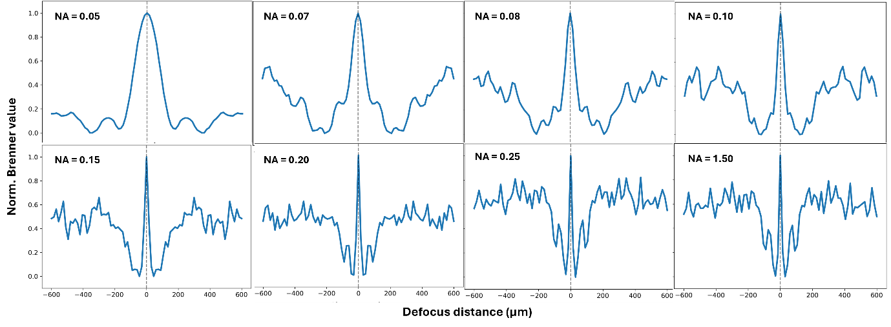Figure 1 Brenner curves for amplitude object across defocus range at different apertures
But, for phase objects which are transparent in nature, the contrast is manifested in non-linear ways often deviating from a proper maximum or minimum condition. This is a problem for computational autofocusing. For accurate autofocusing we need to know how these phase objects behave on a metric curve for an optical system.
Capturing phase variations is a formidable task owing to the camera capturing only intensity variations. For highly transparent pure phase objects, the intensity contrast at the focal plane is almost negligible. The Transport of Intensity Equation (TIE) [equation 2] physics predicts the conversion of invisible phase variations into amplitude variation on defocusing the object plane.
$$\frac{∂I}{∂z}∝-∇^{2}ϕ$$ | (2)
where I is the intensity variation along the optical axis ($z$) to the phase profile $ϕ\left(x,y\right)$ of the object. Phase objects show intensity variations when defocused. Naturally, Brenner curve would show a minimum for the focal plane. At the optimal focus, this would give a minimum on the Brenner curve as shown in Figure 2.
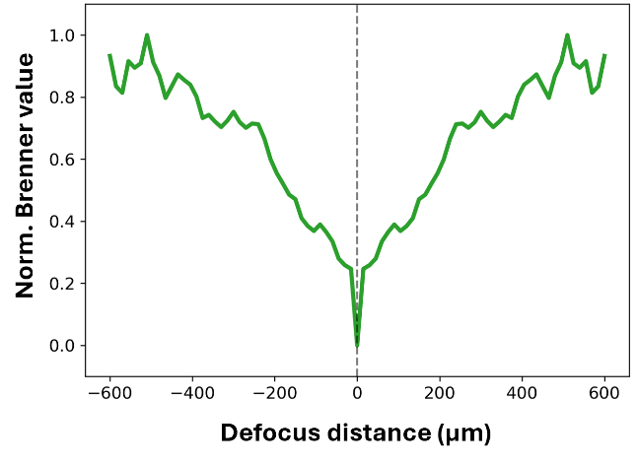
Figure 2 Brenner curve: minimum for slowly varying (weak) phase object captured by high NA lens
Wide Field-of-View techniques like Fourier Ptychography Microscopy require low NA objective lens. Instead of showing a true minimum at the focal position, it gives a strange peak on the Brenner curve as shown in Figure. This poses a problem for accurate autofocusing of the system. This work aims to achieve a better understanding of the ways in which phase objects interact with finite apertures and defocus.

Methodology
The objects are simulated as a function field with both amplitude and phase part. For amplitude part, standard cameraman image has been taken and for phase objects moon image from the data is used. Parameters like smoothness and strength has been managed to simulate different type of phase objects, shown in Figure 2.
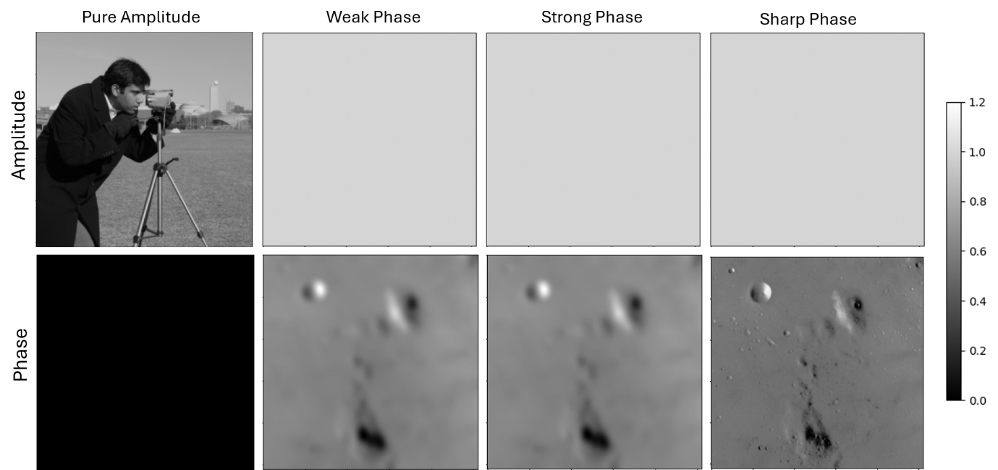
Figure 2 Simulated objects; (Top row) amplitude part of the object function, (bottom row) phase part of the object function
The images are of the size $512 × 512$. The equation is as follows,
$$O = A.e^{(iφ).c}$$ | (3)
where A is the amplitude function and $φ$ is the phase part and c is some constant determining the strength of the phase. For simulating weak and strong phase (slowly varying) functions, the phase part (moon image) is passed through a Gaussian filter to smoothen out the step edges.
Different NA values ranging from 0.05 to 1.5 were used to simulate the pupil function to study the effect of finite aperture imposed by the objective lens on the captured images.

3. Results
The Brenner value should gradually increase as we move away from focus position, but it is not that straightforward when we look at the curve at large defocus distances. There is inherent blurring (broadening of PSF) which also influences the intensity variations of the captured image. So, two competing factors; first, TIE physics which increases intensity contrast on defocus and second, blurring which decreases the contrast by smoothening out sharp intensity variations, both influence the Brenner values. This is evident in all the curves presented.
Light is diffracted based on the phase profile of the object. Objects with fast varying phase profiles diffract light at larger angles. Similarly, uniform phase profiles have a finite angular range of diffraction. This diffracted light is then captured by the finite aperture of the objective lens. Objective lens acts as a low-pass filter in the Fourier space. For a slowly varying object which diffract lights in a finite angular range, the objective lens of sufficient numerical aperture captures almost all the frequency spectrum.
Low NA lens captures part of the diffracted spectrum. According to continuous optical physics, a pure phase object requires infinite spatial bandwidth to maintain zero amplitude contrast at focus. But physically, at the boundary of the lens, there is a abrupt clipping of the spectrum. The frequency spectrum is now finite and introduces a discontinuity at the boundary. This discontinuity introduces ringing artifacts in the spatial domain. This is known as Gibbs phenomenon. Figure 3 shows Brenner curves for a slowly varying highly transparent phase object on encountering different NA objective lens.
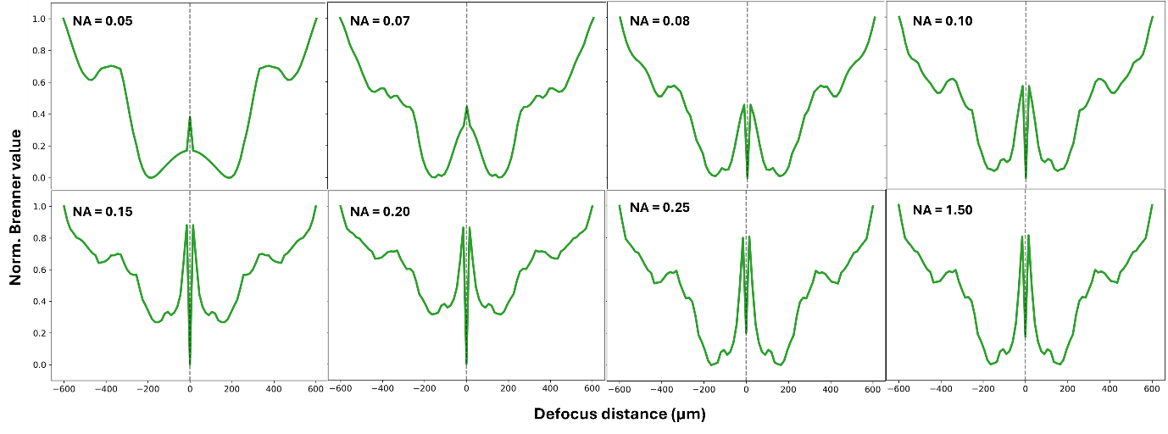
Figure 3 Brenner curves for weak phase object for different NA
Figure 3 shows peaks instead of predicted minimum for low NA values (NA = 0.05, 0.07). This is attributed to the sharp intensity variations introduced due to these ringing artifacts. For higher NA values the spectrum almost falls to near-zero values in the allowed range of frequencies and thus Gibbs phenomena vanishes and it shows a global minimum which is prominent for even higher values. For NA values of 0.25 and above the minimum are not truly global, this will be discussed later.
For stronger phase objects which have a wider spread of spectrum, the ringing artifacts are more prominent and have a stronger presence on Brenner curves as shown in Figure 4. It takes an even higher value of NA (compared to weak phase object) to observe a global minimum.
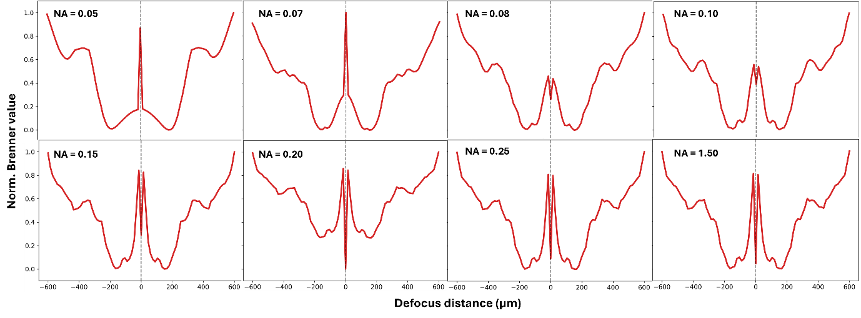
Figure 4 Brenner curves for strong phase object for different NA
Highly scattering phase objects with fast variations of phase have a broad spectrum in Fourier space. The spectrum falls to near-zero values at very large frequencies. The Gibbs phenomena act up for lower NA and false peaks are observed. As we increase the NA values, the Brenner curves show predicted minimum values. But for higher NA 0.25 and above it strangely shows a strong peak on the Brenner curve as shown in Figure 5. This is due to Gibbs artifacts due finite camera pixels.
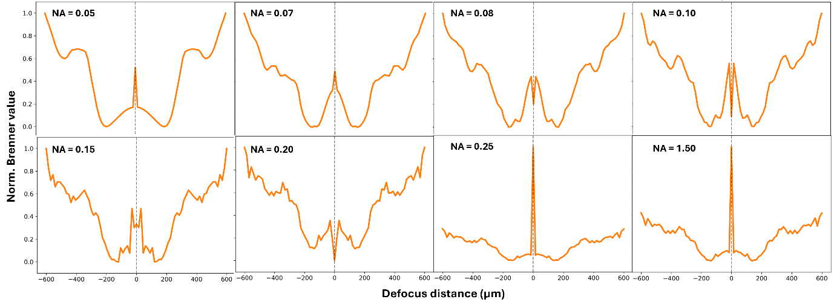
Figure 5 Brenner curves for strong phase object for different NA
Physically, the camera pixel size also constrains the Fourier domain, it determines the bandwidth of the frequency spectrum. Frequencies beyond the bandwidth would be clipped and would introduce sharp diffraction ringing again, due to Gibbs phenomena. Numerical aperture would behave as a circular pass filter with radius given by $NA/λ$ and the pixel size constraint would be manifested as a rectangular aperture with maximum frequency given by
$$k_{max} = \frac{1}{2×pixel size}$$ | (2)
For low NA the circular filter falls within the rectangular aperture and Gibbs artifacts arise due to clipping by circular aperture. For higher NA, the rectangular aperture is inside the circular aperture. Sudden discontinuity at boundaries of rectangular aperture is manifested as convolution with sinc function in spatial domain generating Gibbs artifacts.
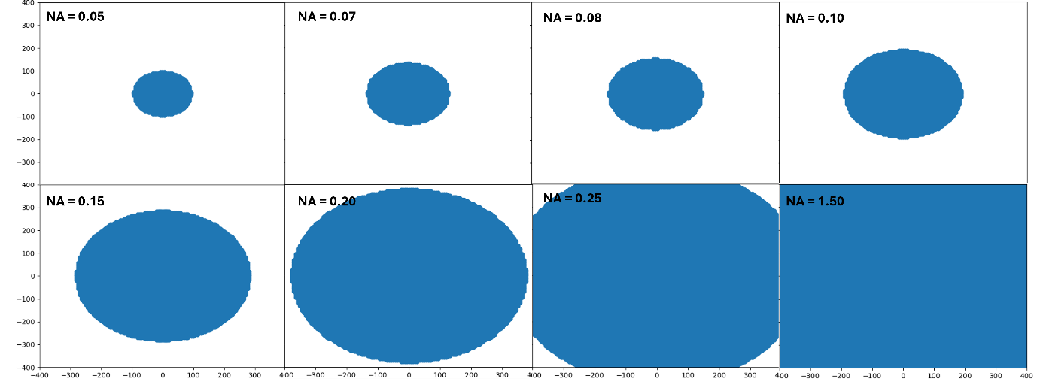
Figure 6 Allowed frequencies for the physical optical setup depending on the NA and the pixel size of the camera.
Figure 6 figuratively depicts the circular low-pass filters for different aperture sizes drawn against a rectangular aperture in accords with the pixel size. It can be observed for higher values of NA (0.25 and above), clipping due to pixel size takes over because circular low pass filter goes beyond the rectangular aperture (allowed frequencies by objective lens are higher than bandwidth of the optical system).
Nature of the phase object highly influences the artifactual presence in the spatial domain and peaks on the Brenner curve. Figure 7 shows Brenner curve for weak, strong and sharp phase profiles for NA = 0.25 (Constrained by pixel size and limited by bandwidth). Gibbs artifact due to clipping by physical pixels is present in all three cases but most prominent in sharp phase object. This is explained by distribution of energy in the Fourier space.
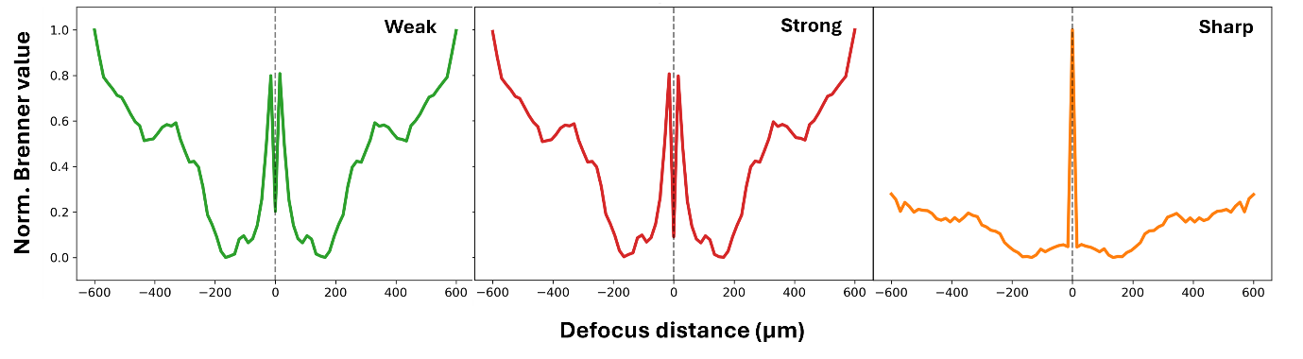
Figure 7 Brenner curves for weak, strong and sharp phase objects at NA = 0.25
Clearly observed is the spread of energies in the frequency domain in Figure 8. The energy in the weak phase spectrum is tightly bundled in the center (the DC component and lowest spatial frequencies). The signal decays to near-zero well before it reaches the outer edges of the frequency space. In the strong phase spectrum, the energy is spreading outward into a broader halo. The spatial frequencies are higher due to the steeper phase gradients. The spectrum for the sharp phase object shows a massive, cross-shaped distribution of energy (a 2D Sinc function). Because a sharp edge contains infinite spatial frequencies, the energy spreads outward. Notice how the bright streaks slam violently into the rigid, square boundaries of the image window.
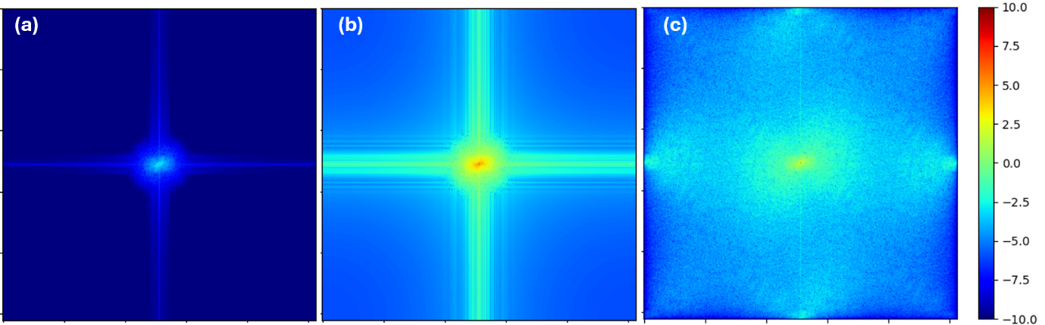
Figure 8 Fourier spectrum (log scale) for (a) weak, (b) strong and (c) sharp phase object
To understand more thoroughly we look at the energy density by power spectral density method through 1D line graph for all these phase objects in Figure 9. The weak phase energy drops rapidly to near zero before the Nyquist limit, while the sharp phase energy violently slams into the Nyquist boundary even after being allowed by the objective lens boundary. Because the optical lens is pushing these allowed frequencies onto the camera, but the camera is mathematically incapable of rendering frequencies past the black line (Nyquist limit), the energy bounces back as square digital aliasing.
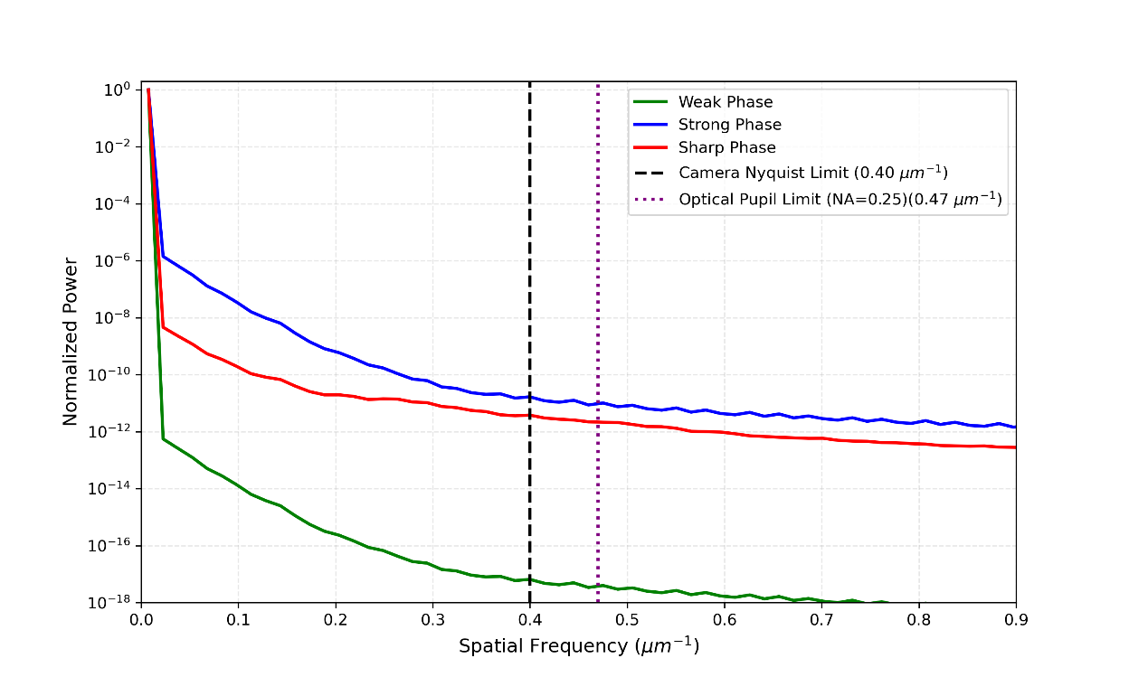
Figure 9 1D line profile for energy distribution against spatial frequencies for different phase objects for NA = 0.25

3. Conclusion
Focusing techniques based on maximization of amplitude-based contrast metrics over range of defocus fails for transparent phase objects. Phase objects have been known to show both peaks and global minimum and in between behavior on these metric curves. These non-linear ways in which phase objects interact with the optical system are influenced by multiple parameters of the system and general optical physics.
TIE physics and blurring due to quadratic phase factor work in a juxtaposing manner by establishing the dominance in the amplitude variations. The local behavior is influenced by the physical parameters like finite aperture introduced by objective lens and bandwidth determined by physical camera pixel pitch. These factors contribute to intensity variations by generating aliasing and artifacts.
Gibbs artifacts due to clipping by objective lens of finite aperture is a physical optical limit of the setup and can be treated as a parameter-based situation. But, the artifacts due to limited bandwidth imposed by our finite sized camera pixel are an inherent property of the optical system. How these two altogether influence the acquisition is out of scope of this study and can be explored in future studies.

Supplementary

2. Frequency Limits

2.1. Pupil Limit
The optical limit imposed by the objective lens is given by equation for allowed frequencies given by $NA/λ$. For NA = 0.25 and $λ$ = 0.539 µm, it is calculated at $0.47 μm^{-1}$. Depending upon the Fourier spectrum, frequencies beyond this limit decay and does not contribute in far-field acquisition.

2.2. Nyquist Limit
The bandwidth of the imaging system is determined by the physical sensor size of camera called the pixel pitch. The maximum frequency readable by the system is given by equation 2. For simulation, the pixel size is $2.5 μm$ and magnification $2×$, the bandwidth of the system is established at $[-0.40 μm^{-1}, 0.40 μm^{-1}]$.

For calculations of frequency limits, see supplementary section 2

